
  Stonefield Surgery
  Milnrow & Newhey Medical Centre
  Newhey Road, Milnrow
  Rochdale
  OL16 4JQ
Patient Participation Group

MINUTES of PPG Meeting held on Wednesday 21st October 2026 @ 4.30pm

Attendees: Apologies:
Brian McGill (Chairman) Karen Black
June Ghilene (PPG Secretary) Neil Butterworth Kay Harrison Barry Sanderson
Liz Brookes
Jo Lees (Practice Manager)
Dr Sarah Crowley

 | Discussion Item | Action/Resp
1 | Review of previous minutes  Minutes of previous meeting passed as true record | Fact
2 | Awareness Events  October – Breast Cancer Awareness month. We held a coffee morning at the surgery with a raffle and raised £136 for Breast Friends charity. The patients chatted to the Ambassador Julie Barber.  The list of events was shared with the group. Month of November the group showed an interest in Pancreatic cancer awareness.  November – Poppy Appeal. The Veterans will be on site on 6th & 9th November for donations for the Poppy Appeal and will have merchandise available for donations, i.e. badges, pens, | Fact
3 | Practice Update  Given by Jo Lees (Practice Manager and Dr Sarah Crowley)  - Online access has now changed from Patchs to Accurx which is much better. The form is straight forward, actioned in the same way and is much quicker. All patients have been advised by the practice of the changeover.  - Abtrace - Another new system was introduced called Abtrace which will automatically send patients a message when their regular Reviews are due, i.e. hypertension, health checks etc. saving time for staff having to ring or message patients to attend for their Review.  - Phones – a new phone system has been introduced with many benefits for patients and staff.  - EMIS system - The partners are looking into a new system to replace EMIS – update to follow at next meeting  - Staffing – We have new trainee doctors  - Extended Access – the practice now offers Tuesday evening extended access 6.30pm – 8pm and alternative Saturdays. Appointments are available to see a GP, Nurse or Health Care Assistant and can book a Spirometry, an Echo Cardiogram, etc.  - Nurses appointments – have changed to 20 mins (was 10 mins) to enable more in-depth assessment and reviews.
4 | DNA’S – Patients who ‘Did Not Attend’ their appointment.  YOY comparison (as per graph below) | Fact
5  6 | Friends & Family Results for September 2026  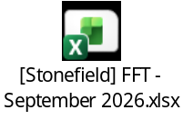  Registered Patients
7 | Google Reviews  We are working together with Primary Care Growth Strategies to improve our rating for Google reviews. Since working with them, our reviews have massively increased receiving 604 reviews 4.8 star mostly 5* reviews.  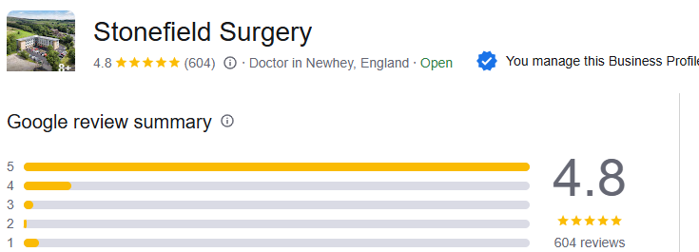  We send a message via Accurx out to all patients daily who have had an appointment that day to encourage them to respond with a google review.  - June to look at adding a strapline to the daily message that goes out to all patients re Recruitment drive to join PPG.  Number of messages sent to patients in September: 1670
8 | A.O.B  - Liz Brookes expressed an interest in taking part in a video for our face book page on Dementia and Delerium. Hopefully she will do a short video on a recruitment drive to join our PPG.  - Next meeting will be 16th December (Christmas Party) all to bring some snacks and (Neil – don’t forget the samosas) | Fact

2026 Meeting Dates @ 4.30pm
Wednesday 18 February 2026
Wednesday 15 April 2026
Wednesday 17 June 2026
Wednesday 19 August 2026
Wednesday 21 October 2026
Wednesday 16 December 2026 (Christmas party)

