 | Stonefield Surgery  Milnrow & Newhey Medical Centre  Newhey Road, Milnrow  Rochdale  OL16 4JQ
Patient Participation Group

MINUTES of PPG Meeting held on Wednesday 16th April 2025 @ 4.30pm.

Attendees: Apologies:
Brian McGill (Chairman) Kay Harrison
June Ghilene (secretary) Barry Sanderson
Karen Kelland
Neil Butterworth
Karen Black

Dr Sarah Crowley

 | Discussion Item | Action/Resp.
1 | Review of previous minutes  Minutes of previous meeting passed as true record by Karen B Seconded by Karen K. | Fact
2. | New Members & Resignations  New Member : Jacqui Mellor – will be welcomed at the next meeting  No Resignations | Fact
4 | Topic of the Month – DNA  DNA’S – Patients who ‘Did Not Attend’ their appointment.  March 154 (Jan 170 / Feb 162)  Number is coming down compared to 286 in July last year.  Work is in progress to reduce this.  At the last meeting Neil asked June to compile a comparison of patients who DNA’d for a GP appt compared to a Nurse Appt and produce a chart.  June monitored every clinic daily for a 5 week period to produce the below.  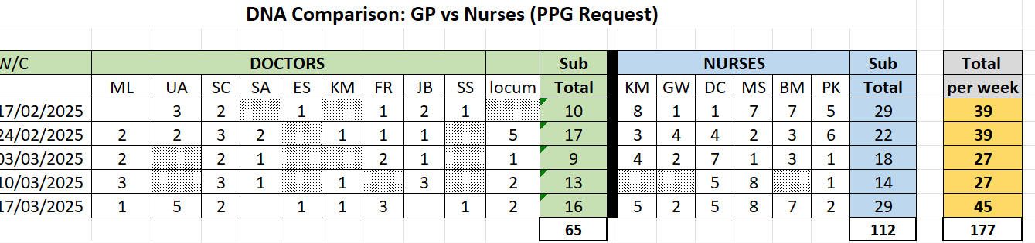  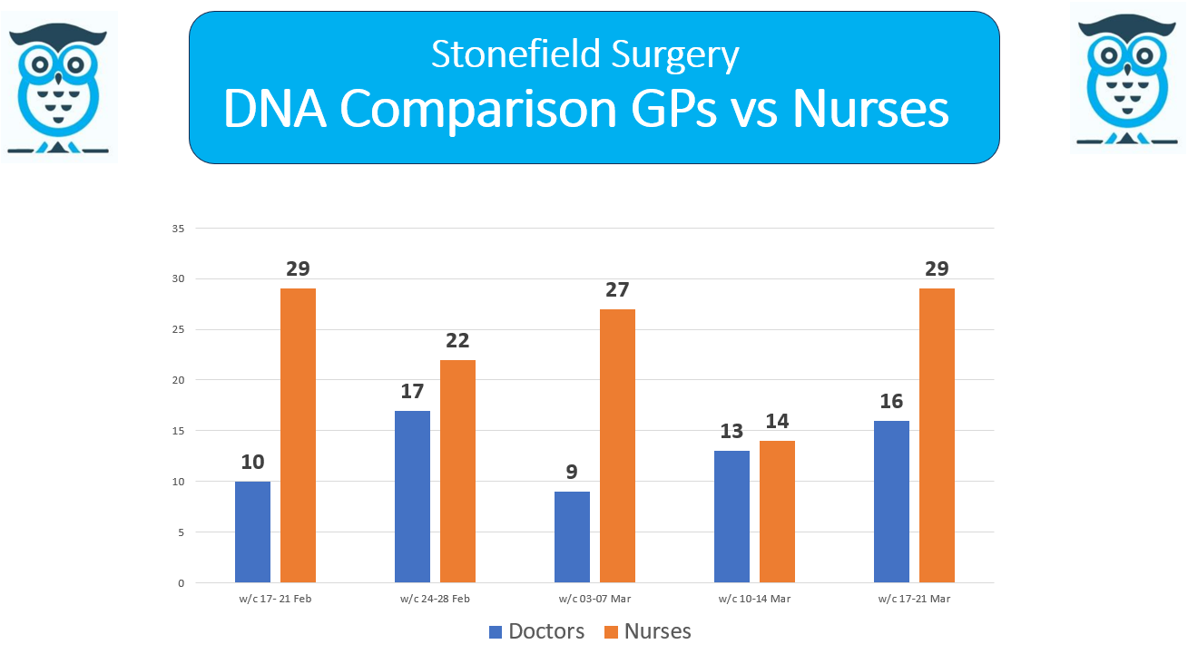  We now need to establish going forward, what the pts are booked in for, i.e. bloods, smears, routine appt etc., etc. June will monitor for a few weeks and report at the next meeting.  Also monitoring DNA’s YOY Comparison to check if we are improving.  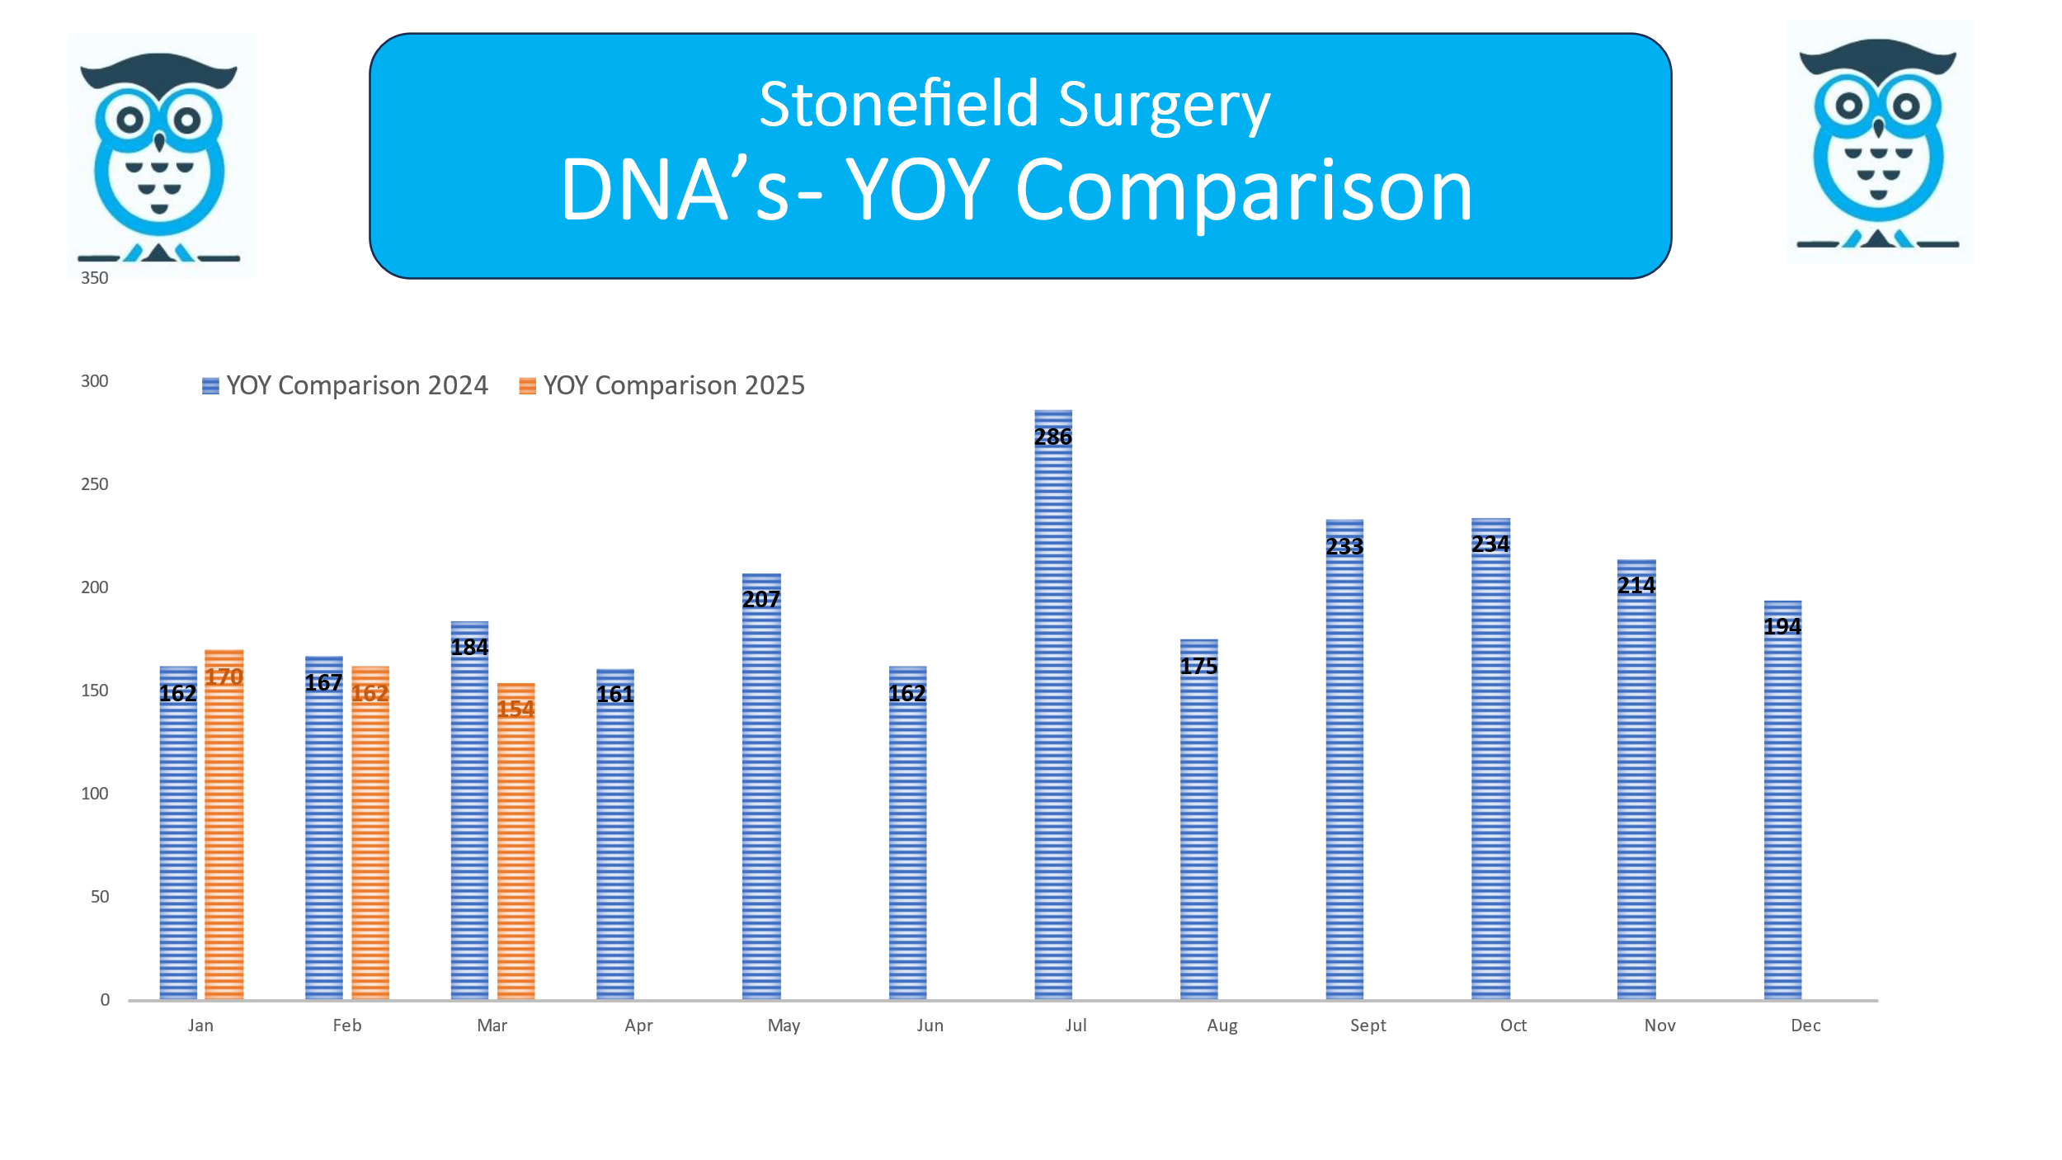 | JGh
5 | Friends & Family Results  March 2025 - 21% Response Rate / 1112 Appointments = 231 Responses  February 2025 - 22% Response Rate / 1124 Appointments = 246 Responses  January 2025 - 23% Response Rate / 1352 Appointments = 317 Responses  Registered Patients  June circulated the graph to show how patient registrations are growing. | Fact
6. | Google Reviews  We are working together with Primary Care Growth Strategies to improve our rating for Google reviews. Since working with them, our reviews have massively increased in the last few months with us receiving 4.7 star review with 239 mostly 5* reviews.  We are aiming to achieve the strapline:  ‘Stonefield’s reputation is the best surgery in Rochdale’.  
7. | Practice Update  Dr Crowley gave a practice update and answered many questions.  1 GP leaving (Dr Bishop) and 1 GP returning 1st May (Dr Santhosh Panicker) for Thursdays/Fridays.  2 new receptionists starting in the next 2 weeks.
8. | - Patient Voice – Recruitment for PPG members  - June to create poster for screens (see below)  - Collaboration  - Local H&SC service awareness  - Patient information – what matters to you.  - Feedback (You said, we did)
9. | A.O.B  Recruitment Drive – New PPG members  Poster created and is now displayed on the screens in the waiting rooms and posters are in reception.  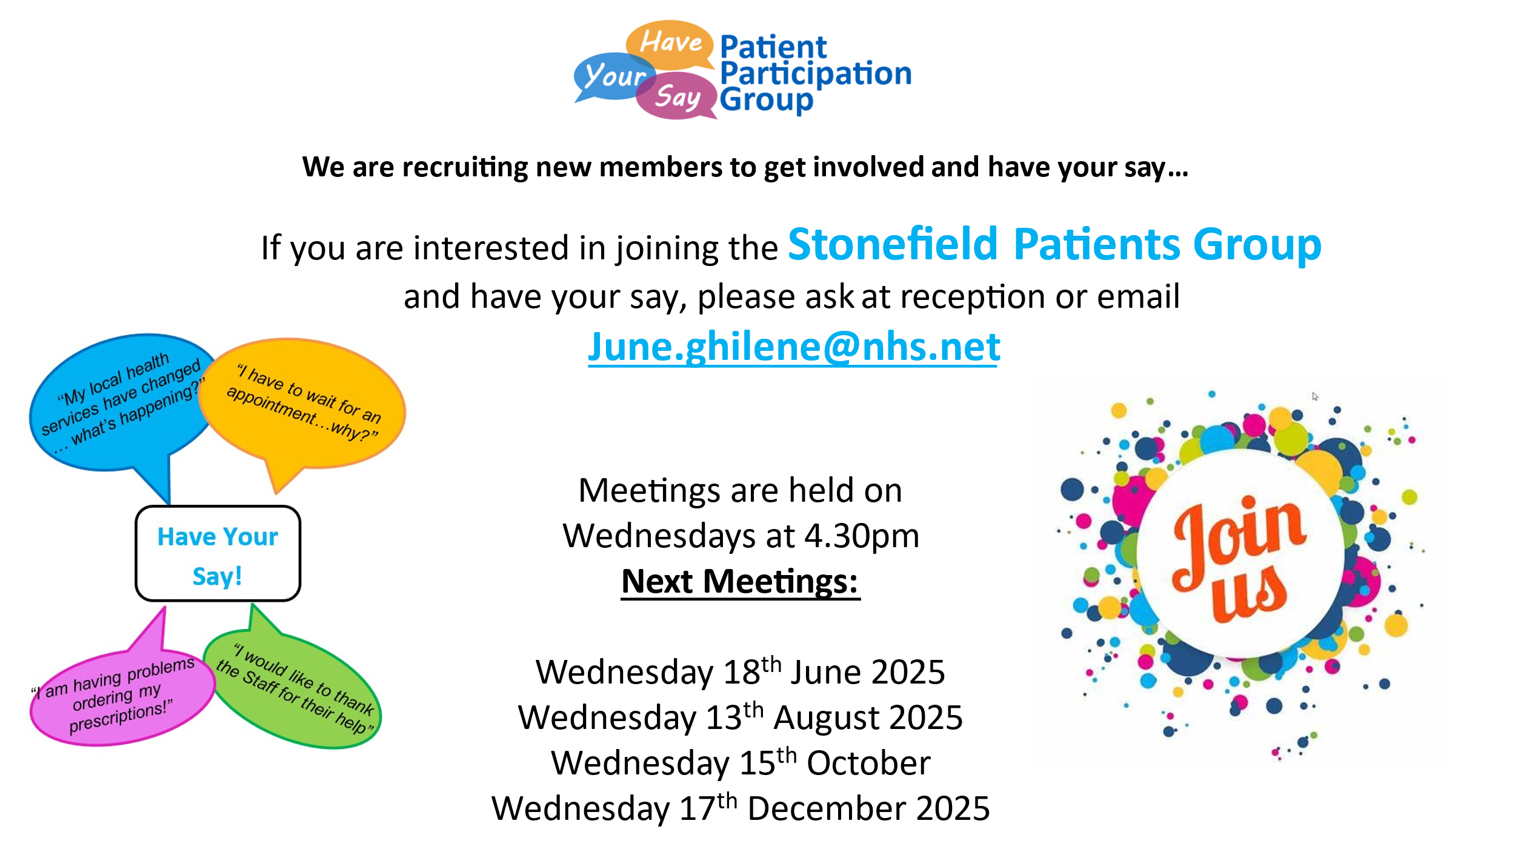  Also A5 size leaflets in reception for patients to take away.  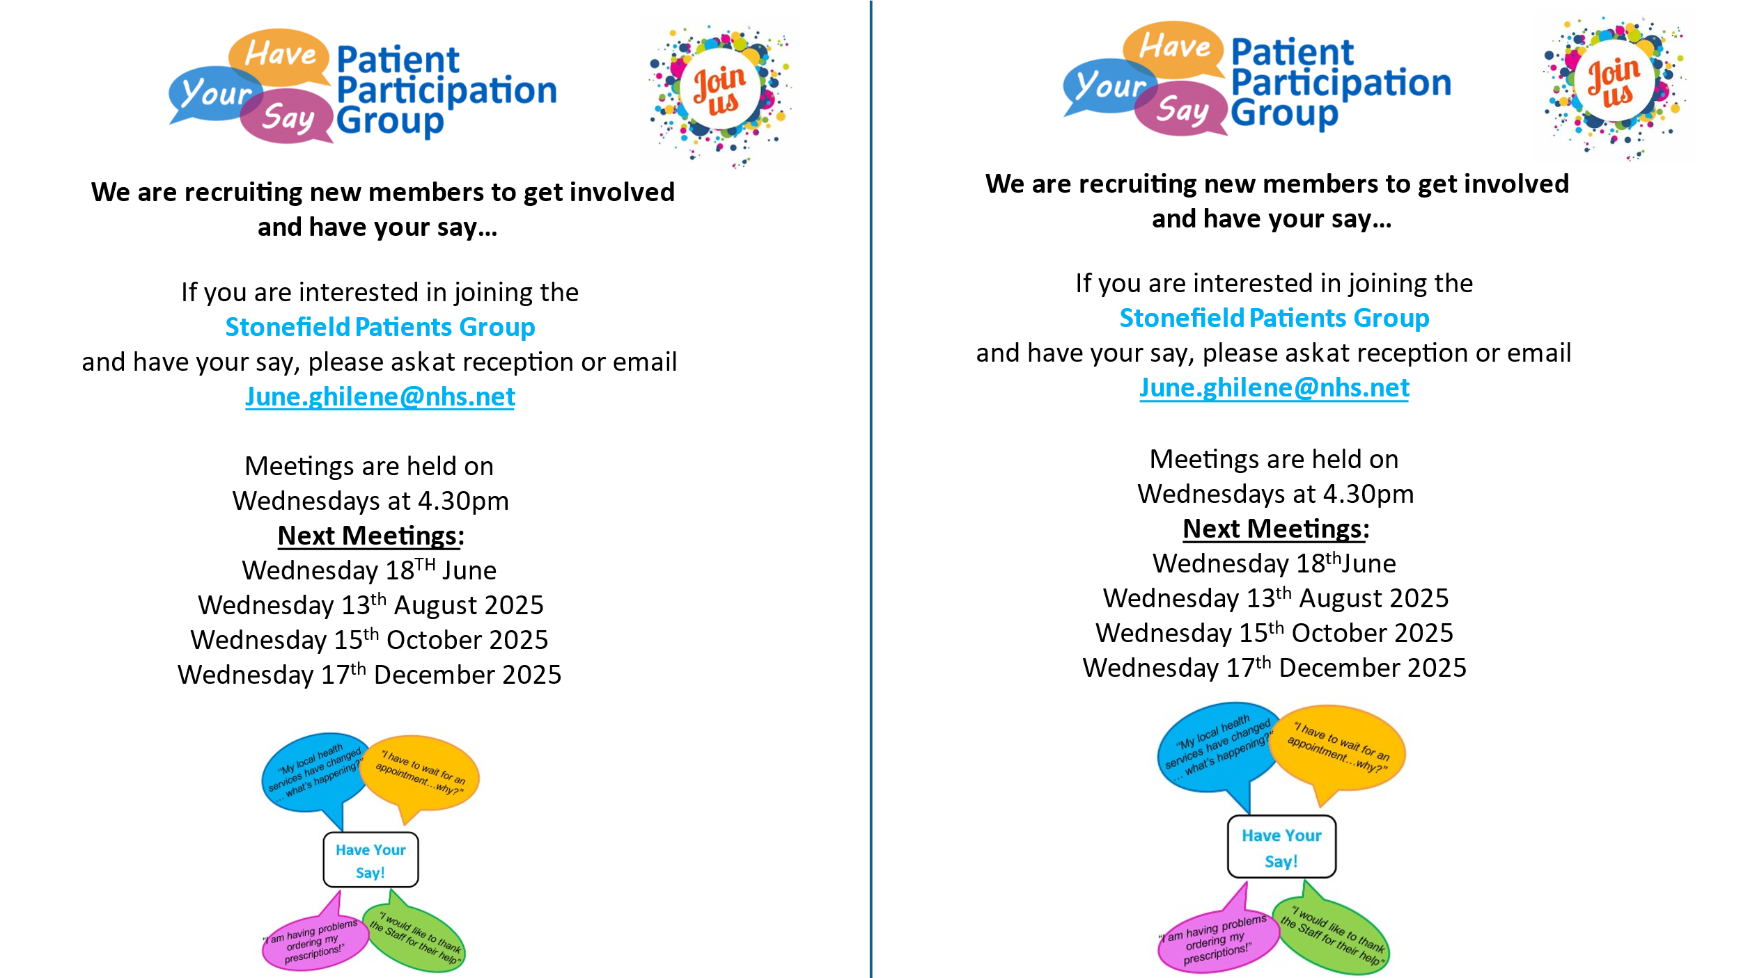 | Fact

2025 Meeting Dates / 4.30pm
Wednesday 12 February
Wednesday 16 April
Wednesday 18 June
Wednesday 13 August
Wednesday 15 October
Wednesday 17 December

