 | Stonefield Surgery  Milnrow & Newhey Medical Centre  Newhey Road, Milnrow  Rochdale  OL16 4JQ
Patient Participation Group

MINUTES of PPG Meeting held on Wednesday 18th June 2025 @ 4.30pm.

Attendees: Apologies:
Brian McGill (Chairman)
June Ghilene (secretary) Neil Butterworth
Barry Sanderson Karen Kelland
Kay Harrison
Karen Black
Jacqui Mellor

Dr Sarah Crowley
Dr Kyle Millar

 | Discussion Item | Action/Resp
1 | Review of previous minutes  Minutes of previous meeting passed as true record by June Ghilene Seconded by Brian McGill | Fact
2 | New Members & Resignations  New Member : A warm welcome to our new member Jacqui Mellor. Jacqui was asked by the chairman how she heard about the group and she replied from the noticeboard in reception.  No Resignations | Fact
4 | DNA’S – Patients who ‘Did Not Attend’ their appointment.  May 142 - April 125 - March 154 – Feb 162 – Jan 170  Number is coming down compared to 286 in July last year.  Work is in progress to reduce this.  At the last meeting Neil asked June to compile a comparison of the type of appointments that had DNA’d i.e. bloods, smears, routine appt etc., for a GP appt compared to a Nurse Appt and produce a chart.  June monitored every clinic daily for a 3 week period to produce the below charts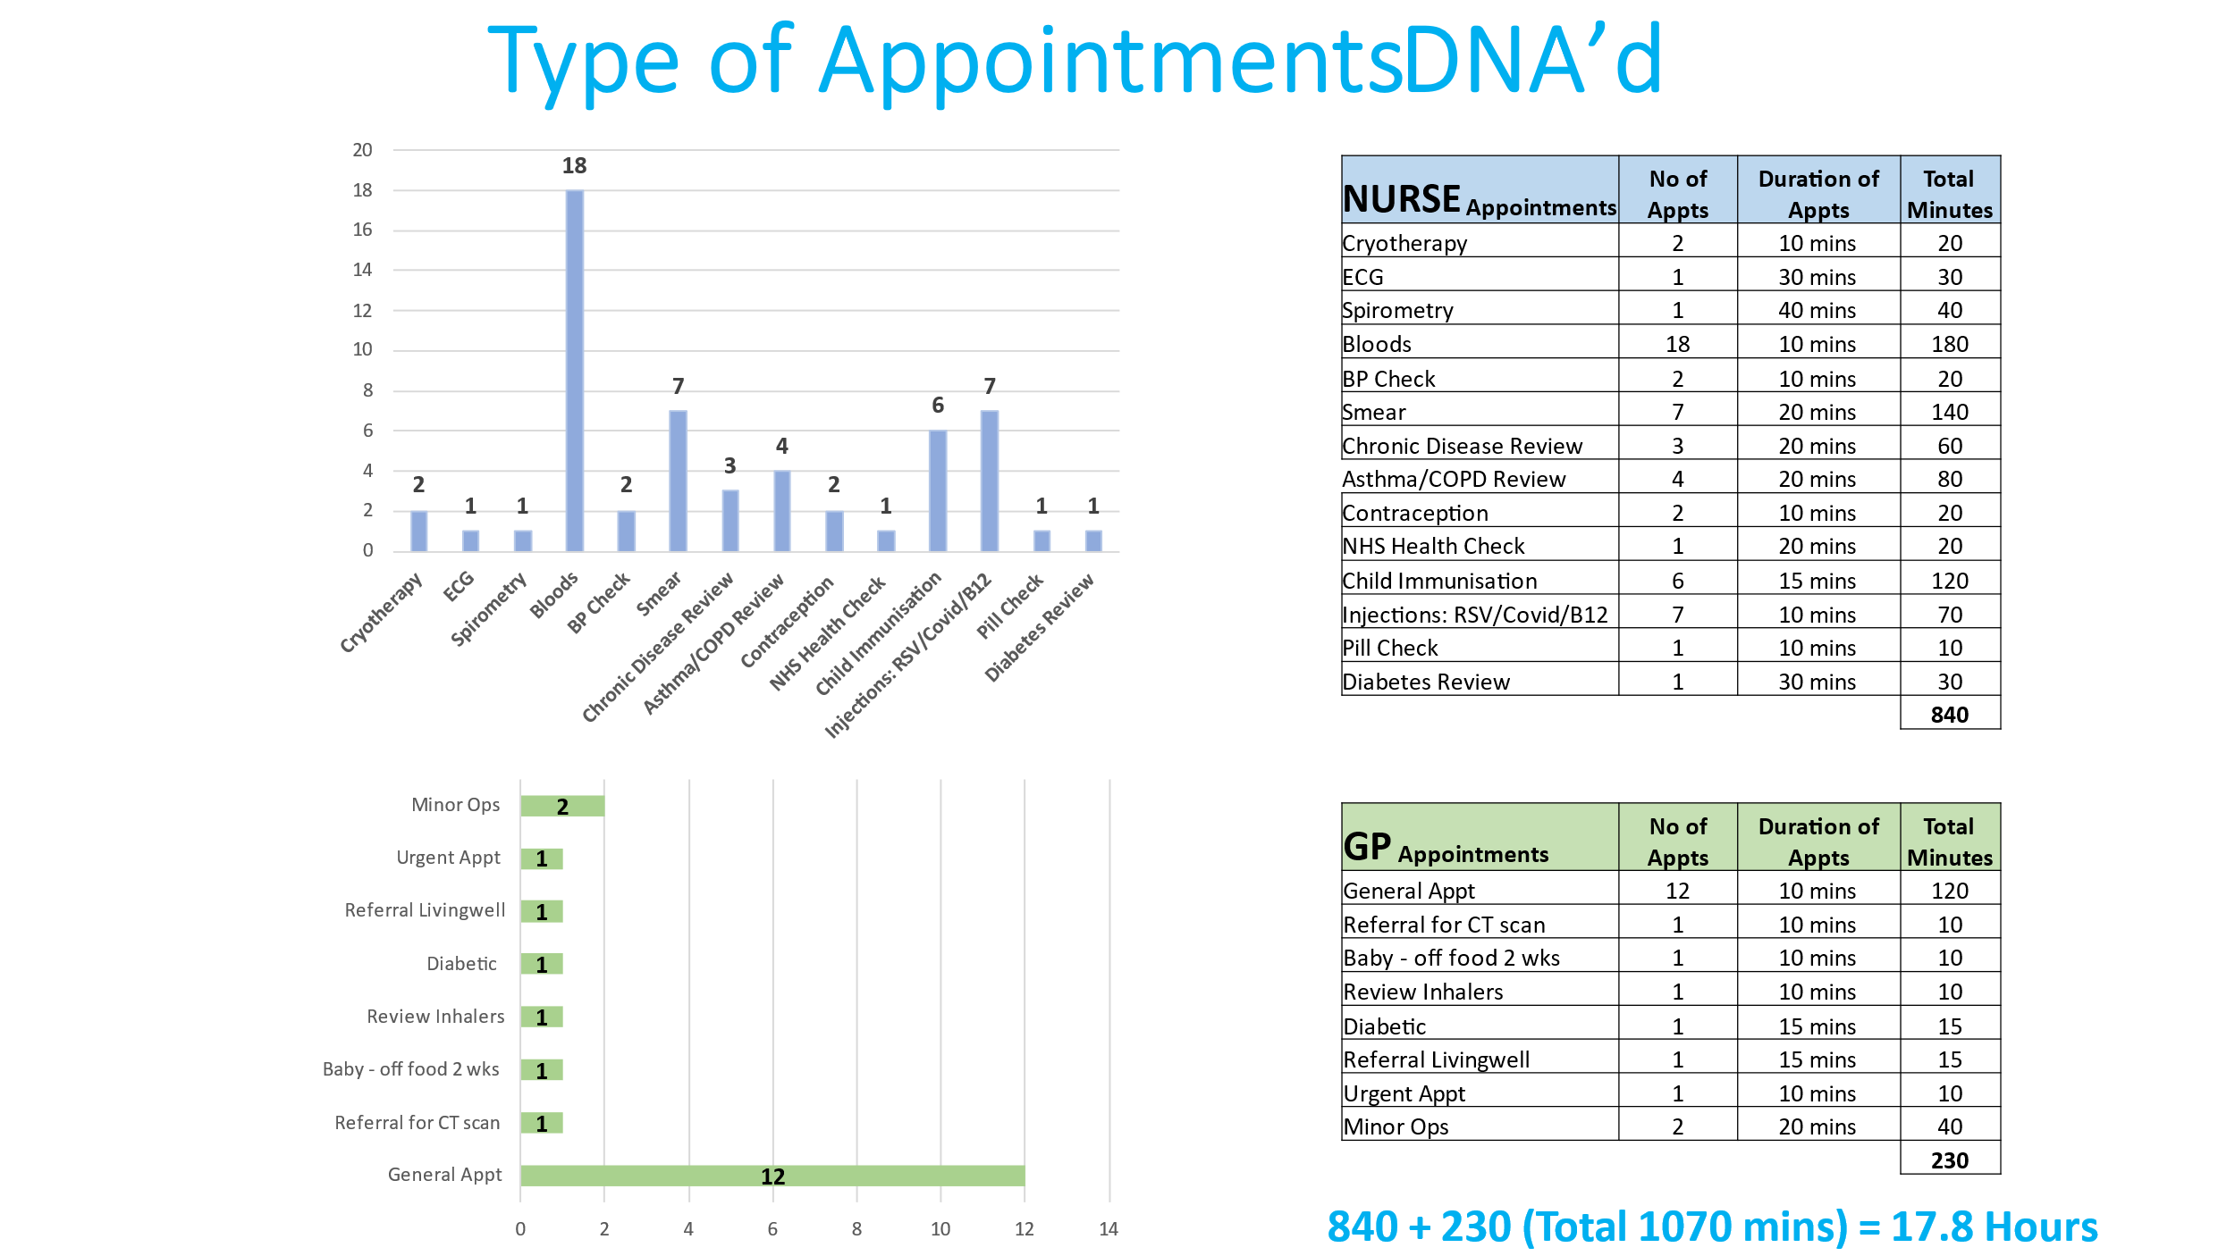  Jacqui asked if it would be possible to have a separate phone number for the cancellation line to cancel appointments rather than wait in the queue. JG checked the line and the option to cancel an appt is in the initial message (before going in the queue) to cancel an appointment Press 0, therefore there is no need for a separate line.  June also monitors DNA’s YOY Comparison to check that we are improving.  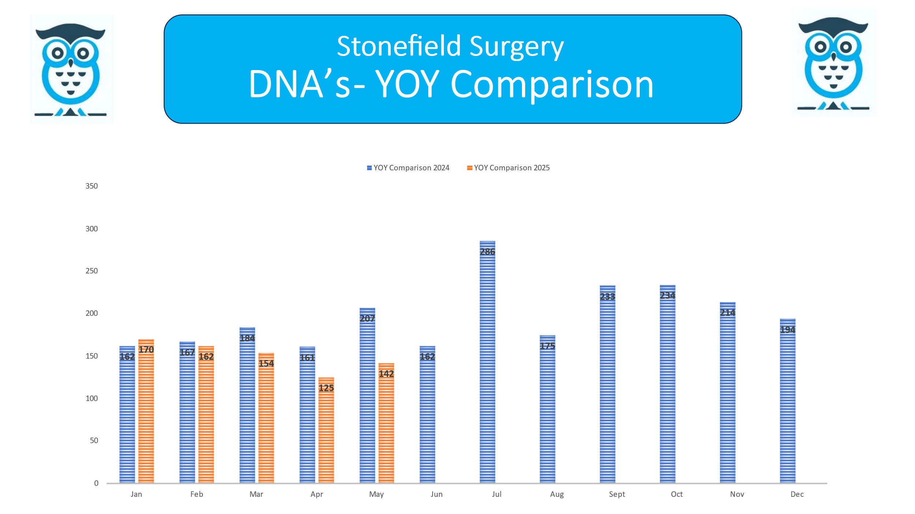 | JGh  Fact
5 | Friends & Family Results  May 2025 – 18% Response Rate / 1150 Appointments = 205 Responses  April 2025 – 20% Response Rate / 1276 Appointments = 257 Responses  March 2025 - 21% Response Rate / 1112 Appointments = 231 Responses  February 2025 - 22% Response Rate / 1124 Appointments = 246 Responses  January 2025 - 23% Response Rate / 1352 Appointments = 317 Responses  Registered Patients  June circulated the graph to show how patient registrations are growing. | Fact
6 | Google Reviews  We are working together with Primary Care Growth Strategies to improve our rating for Google reviews. Since working with them, our reviews have massively increased in the last few months with us receiving 4.7 star review with 296 mostly 5* reviews.  
7 | Practice Update  Dr Crowley gave a practice update and answered many questions.  Interviews for another receptionist are going ahead this week.  3 new Trainee GPs starting in the next couple of months.  The Partners are looking at an automated appointments line, however this is work in progress and not sure if it will go ahead at this stage until further investigations take place.  Dr Crowley asked the PPG if they would like to take part in a video (see facebook for videos that the partners have filmed) Speak to June if interested.  The Chairman raised a question “Why are appointments only available 2 weeks in advance and not longer”?  Clinics are added to the system 1 month at a time, each clinic (to ensure a range of appointments are available each day) are broken down as follows:  - Appointments available to pre-book  - Appointments that open up 7 days prior to the clinic  - Appointments that open up 14 days prior to the clinic  - Appointments that are reserved for urgent on the day
8 | A.O.B  NHS App – most members are signed up for the NHS App – June advised about the patient session mid July (date tbc) and that the NHS Digital team will be present to promote the App and help patients sign up. Once date received, members to check their availability to help out at the event.  Recruitment Drive – New PPG members - A5 size leaflets in reception for patients to take away.  Question raised to ask other practices in the PCN if their PPG group would be interested in meeting up once or twice a year to share information and get ideas from each other. | Fact  Fact  Jo Lees
Topics to cover going forward

1. Patient Voice – Recruitment for PPG members
2. Collaboration
3. Local H&SC service awareness
4. Patient information – what matters to you.
5. Feedback (You said, we did)

2025 Meeting Dates / 4.30pm
Wednesday 12 February
Wednesday 16 April
Wednesday 18 June
Wednesday 13 August
Wednesday 15 October
Wednesday 17 December

